Participating in a Zoom Start Guide
Zoom Meeting
Participating in a Zoom Meeting Quick Start Guide
This quick start guide gives you an introduction to the essentials of joining and participating in a Zoom meeting.
Zoom is a cloud-based meeting platform that provides video, audio, and screen sharing options across multiple platforms, including mobile. You can join any Zoom meeting by clicking the meeting URL, or by entering the meeting ID into the Zoom Web Portal, the desktop app, or mobile app.

Join a Meeting

Join a Meeting via URL
- Click the Meeting URL provided by the host.
- If necessary, follow the prompts to download and install the Zoom desktop application.
NOTE: You will need to download and install the Zoom desktop application to use meeting chat and participate in polls.

Join a Meeting via the Zoom Web Portal
- Open a web browser and navigate to the Zoom Web Portal at https://psu.zoom.us/.
- Click Join (Connect to a meeting).
- Enter the Meeting ID into the field. The meeting ID is the 9, 10, or 11-digit number located in the meeting invitation or at the end of the Zoom meeting URL.
- Click Join.
- If necessary, follow the prompts to download and install the Zoom desktop application.
NOTE: If the host has decided not to allow participants to join before the host, you will see a message appear on your screen and you will automatically join the meeting when the host arrives.
The Zoom meeting window is displayed. A menu bar containing participant tools appears at the bottom of the Zoom meeting. This menu bar will appear and disappear as you roll your mouse over the area. If a meeting is being recorded, an icon will appear at the top of the window.
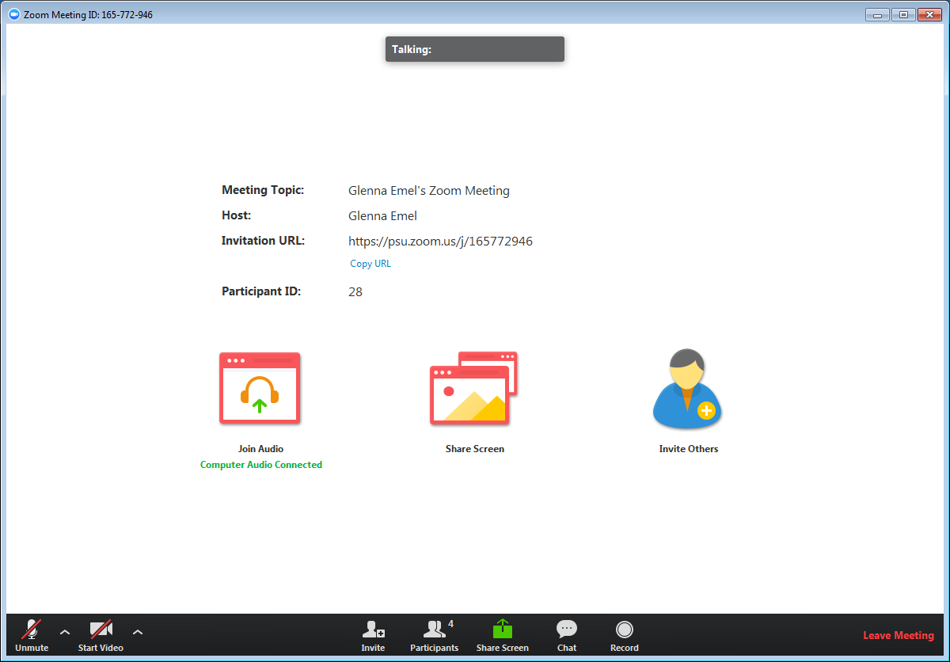
Figure 1: Participant meeting interface with no video or screen sharing displayed.
NOTE: Mobile app interfaces will appear differently but contain most of the same functionality. For help with using Zoom on iOS and Android devices, visit the Mobile section of the Zoom Help Center.

Join a Meeting Using the Zoom Desktop Application

To Join a Meeting with a URL or Meeting ID
- Open your Zoom desktop application.
- Click Join in the Zoom menu. 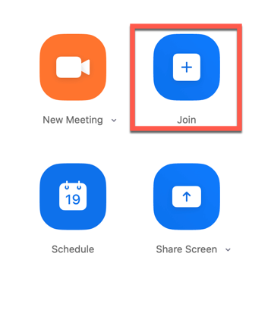
Figure 2: The Join button in the Zoom menu.
- Enter the URL or meeting ID in the Enter meeting ID or personal link name field.
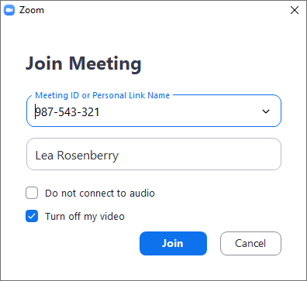
Figure 3: The Meeting ID or Personal Link Name Field.
- Click Join.

To Join/Launch Your Personal Meeting Room
- Open your Zoom desktop application.
- Click the dropdown tab next to New Meeting.
- Check the checkbox next to Use my Personal Meeting ID (PMI).
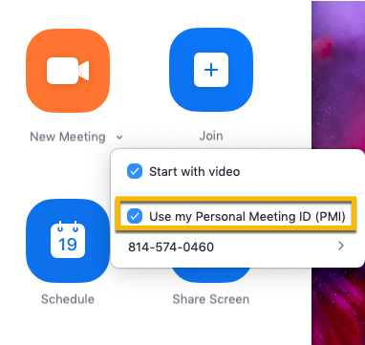
Figure 4: The Join popup with checkbox options.
- Click the camera button above New Meeting to launch your personal meeting room.

Mute/Unmute Audio and Adjust Audio Options
Using audio in a Zoom meeting requires you to have access to either a microphone through your computer or a telephone. Please be aware that the host can control participant audio in a meeting. This means the host can mute and unmute you at any time. Check the icons in the menu bar and the participants panel to determine your current audio setting.
- To unmute yourself and begin talking, click the Unmute button (microphone) in the bottom-left corner of the meeting window.
- To mute yourself, click the Mute button (microphone). A red slash will appear over the microphone icon indicating that your audio is now off.
- To test your computer microphone and speakers, click the up arrow to the right of the microphone icon and select Audio settings.
NOTE: You can switch to a different audio input device using the Audio Options button. If you have joined the meeting via computer audio, be sure to leave computer audio before dialing in to the meeting via the phone.

Start/Stop Video and Adjust Video options
- Click the Start Video button in the menu bar at the bottom to begin your video.
- Click the Stop Video button to stop sharing your video stream.
- To choose a different webcam or adjust your video settings, click the up arrow to the right of the Video icon and select Video Settings.
NOTE: When video is activated, display options are available in the upper right of the screen and in the upper right of each participant’s window in both Speaker View and Gallery View.
NOTE: If you choose not to turn on your webcam in the meeting and video has been activated, your video window will contain either your name, email address, or a photo, depending on how your profile is set up in the Zoom Web Portal.

Send Messages with Chat
You can send a chat message to all participants in the meeting or privately to specific individuals.
NOTE: When you enter a meeting, any messages posted in chat prior to you joining the meeting are not visible to you in the chat panel.

Send a Message to Everyone
- Click the Chat button in the menu bar to open the Chat panel.
- Type your message in the Text box at the bottom of the panel.
- Press Enter to send the message.
- To save the chat transcript, click the More button at the bottom of the chat panel and select Save Chat.
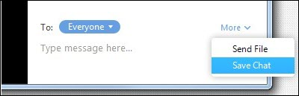
Figure 5: Save chat option selected from the More button at the bottom of the chat panel

Send a Private Message
You can send a private message to a single person by clicking the down arrow in the To: field and selecting the person's name from the list. The person's name will stay selected until you click the down arrow again and select Everyone.

Participate in Polls
The host may ask you to participate in a poll during the session. A poll is typically used for voting or for gathering information from the audience. When the host launches the poll, the poll dialog box will appear on the meeting screen. You can move the poll dialog box to any location on your screen.
- Select the radio button to the left of the desired response.
- Click Submit.
- The poll will disappear from the meeting screen.

Provide Feedback with Nonverbal Feedback Icons
Nonverbal feedback icons allow you to indicate to the host that you have a question, let the host know what you are thinking without interrupting the meeting, and respond quickly to questions or prompts from the host. Nonverbal feedback icons include a raise hand, yes, no, thumbs up, away, etc. This feature must be enabled in both the host and participant's meeting settings in the Zoom Web Portal prior to the meeting.
- Click the Participants button in the menu bar to open the Participants panel.
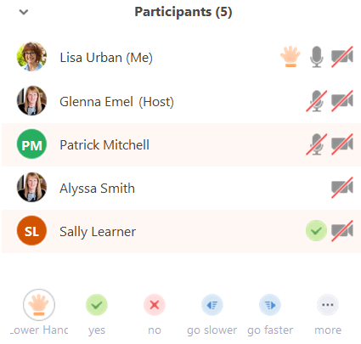
Figure 6: Participant panel displayed with nonverbal feedback icons visible

- Click any nonverbal feedback icon to display the response to the right of your name in the participant panel.
- Click the icon again to clear it.
- Click the …more button to display additional icons, such as thumbs up, thumbs down, etc.
- You can only have a single icon visible at any time. After clicking an icon, clicking a new icon will overwrite the first icon.
NOTE: Be sure to enable non-verbal feedback in your meeting settings in the Zoom Web Portal.

Share Your Screen
Both hosts and participants can share their screen in Zoom. However, participants cannot share if the host is already sharing, or if the host has disabled this feature for participants.
- Click the Share Screen button on the menu bar.
- Select the desktop or application you would like to share or select whiteboard to share a whiteboard. Selecting Desktop will allow you to share everything on your desktop.
- Click the Share Screen.
When sharing your screen, the menu bar moves to the top of your screen and disappears until you roll your mouse over the area. Additional tools, such as Chat, Remote Control, and Audio options are located under the More button. To reposition the menu bar, click and drag it to another location on your computer.
Figure 7: Screen sharing menu bar in expanded view
- If you receive a chat message while you are screen sharing, the More button will blink. To view the chat message, click the More button and select Chat from the list.
- Click the Annotate button to open the annotation menu. Use the draw tools (arrows, shapes) to direct participants' attention to an area of your screen or use the text tool to type notes on the screen.
- Click the X in the upper right of the annotation menu to close the annotation menu.
- Click the More icon to view additional options.
- Click Stop Share in the small menu bar to stop sharing your screen.
NOTE: The host can control who can share their screen, therefore this feature may be disabled in your meeting.

Control Someone Else's Screen
The remote control feature in Zoom allows you to request control of someone else’s screen to share specific content or give another individual control of your screen. This feature must be enabled in both the host and participant's meeting settings in the Zoom Web Portal.
To request control:
- At the top of the Zoom meeting window, in the View Options drop-down list, select Request Remote Control.
- Click the Request button in the dialog box. Once the individual has approved your request, the mini menu bar at the top will indicate that you are controlling their screen.
- To stop controlling a person's screen, select Give Up Remote Control from the View Options drop-down list.
When control is given by someone else:
- When an individual has given you control of their screen, a message will appear and the mini menu bar will change to reflect that you have control.
- To stop the control, select Give Up Remote Control from the View Options drop-down list.
- To stop this feature, click the Remote Control icon in the menu bar again and select Stop Remote Control.
NOTE: If you have shared your desktop, the individual with control will be able to open, edit, or delete any files or programs on your desktop.

Leave a Meeting
- Click the Leave Meeting option in the menu bar to exit the meeting.
- Click the Leave Meeting button in the dialog box.

Participating in a Zoom Meeting Quick Start Guide

